Core Java OOPS -Lab

Class and Object

1. 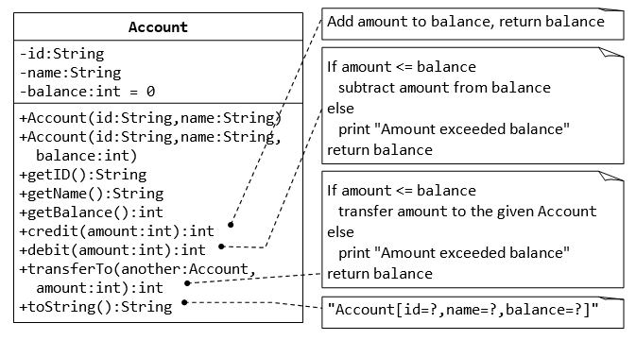

**package** com.accountproject;

**public** **class** Account1 {

String id;

String name;

**int** balance=0;

**int** credit(**int** a1)

{

balance = balance + a1;

**return** balance;

}

**int** debit(**int** a2)

{

**if**(a2 <= balance)

{

balance = balance - a2;

}

**else**

{

System.***out***.println("Amount exceeded balance");

}

**return** balance;

}

**int** transfer(**int** a3)

{

**if**(a3 <= balance)

{

balance = balance - a3;

}

**else**

{

System.***out***.println("Amount exceeded balance");

}

**return** balance;

}

}

**package** com.accountproject;

**import** java.util.Scanner;

**public** **class** account2 {

**public** **static** **void** main(String[] args) {

// **TODO** Auto-generated method stub

**int** a1,a2,a3,res,res2,res3;

Scanner get = **new** Scanner(System.***in***);

Account1 ac=**new** Account1();

System.***out***.println("enter id:");

String id = get.nextLine();

System.***out***.println("enter name:");

String name=get.nextLine();

System.***out***.println("enter amout to credit:");

a1 = get.nextInt();

System.***out***.println("enter amout to debit:");

a2 = get.nextInt();

System.***out***.println("enter amout to transfer:");

a3 = get.nextInt();

res = ac.credit(a1);

System.***out***.println("after credited:" + res);

res2 = ac.debit(a2);

System.***out***.println("after debited:" + res2);

res3 = ac.transfer(a3);

System.***out***.println("after transfer:" + res3);

}

}

Output

enter id:

12

enter name:

kooor

enter amount to credit:

100

enter amount to debit:

300

enter amount to transfer:

40

after credited:100

Amount exceeded balance

after debited:100

after transfer:60

#### 2. Composition- Author and Book Classes

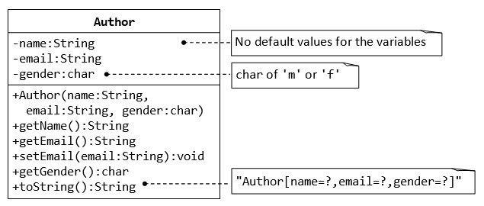

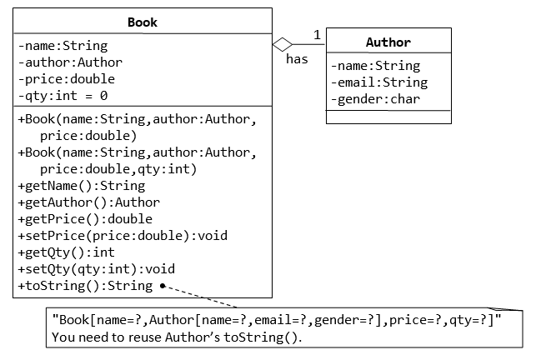

**package** com.authorproject1;

**public** **class** Author

{

**static** String *name*;

**static** String *email*;

**static** **char** *gender*;

**public** Author(String name, String email, **char** gender)

{

**super**();

**this**.*name* = name;

**this**.*email* = email;

**this**.*gender* = gender;

}

**public** String getEmail()

{

**return** *email*;

}

**public** **void** setEmail(String email)

{

**this**.*email* = email;

}

**public** String getName()

{

**return** *name*;

}

**public** **char** getGender()

{

**return** *gender*;

}

@Override

**public** String toString()

{

**return** "Author [name= " + *name* + "email=" + *email* + "Gender= " + *gender* + "]";

}

}

**package** com.authorproject1;

**public** **class** Book **extends** Author

{

String bname;

**double** price;

**int** qty=0;

**public** Book(String bname)

{

**super**(*name*, *email*, *gender*);

**this**.bname=bname;

}

**public** **double** getPrice()

{

**return** price;

}

**public** **void** setPrice(**double** price)

{

**this**.price = price;

}

**public** **int** getQty()

{

**return** qty;

}

**public** **void** setQty(**int** qty)

{

**this**.qty = qty;

}

**public** String getBname()

{

**return** bname;

}

@Override

**public** String toString()

{

**return** "Book[name= " + bname + ",Author [name= " + *name* + ",email= " + *email* + ",Gender= " + *gender* +

"] , price= " +price + ",qty= " + qty + "]";

}

}

**package** com.authorproject1;

**public** **class** main

{

**public** **static** **void** main(String[] args)

{

Author a=**new** Author("koor","koormisharavoor@gmail.com",'F');

System.***out***.println(a);

Book b=**new** Book("7hugygy");

b.setPrice(800);

b.setQty(20);

System.***out***.println(b);

}

}

Output:

Author [name= kooremail=koormisharavoor@gmail.comGender= F]

Book[name= 7hugygy,Author [name= koor,email= koormisharavoor@gmail.com,Gender= F] , price= 800.0,qty= 20]

**3. The Customer and Account Class**

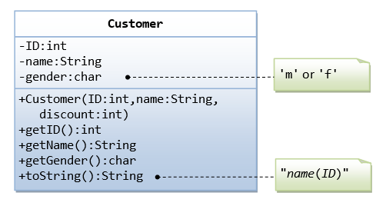

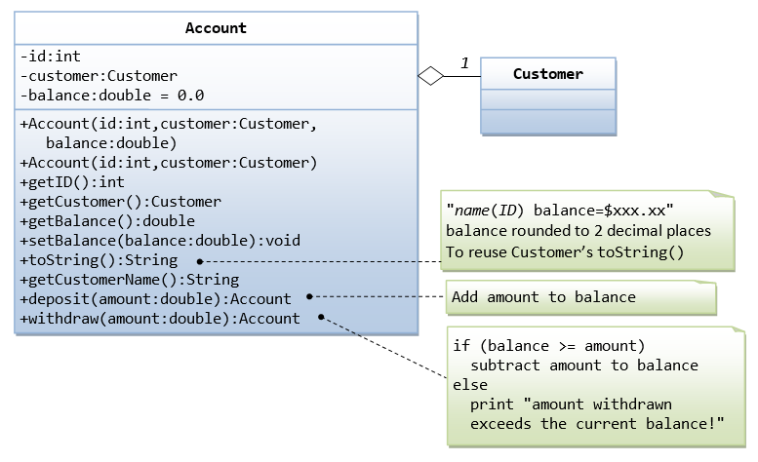

The Account class models a bank account, design as shown in the class diagram, composes a Customer instance (written earlier) as its member. Write the codes for the Account class and a test driver to test all the public methods.

**package** com.accountcustomer;

**import** java.lang.Math;

**public** **class** Account **extends** Customer

{

**int** aid;

**double** balance=0.0;

**public** Account( )

{

**super**(*id*, *name*, *gender*);

**this**.balance=balance;

}

**public** **double** getBalance()

{

**return** balance;

}

**public** **void** setBalance(**double** balance)

{

**this**.balance = balance;

}

**public** **int** getAid()

{

**return** aid;

}

**public** **void** credit(**double** amount)

{

balance = balance+amount;

System.***out***.println("After credit:");

}

**public** **void** withdraw(**double** amount)

{

**if**(balance>=amount)

{

balance=balance-amount;

System.***out***.println("After withdraw:");

}

**else**

{

System.***out***.println("amount withdrawn exceeds the current balance!");

}

}

@Override

**public** String toString()

{

**return** String.*format*("%.2f", balance);

}

}

**package** com.accountcustomer;

**public** **class** Account2 {

**public** **static** **void** main(String[] args)

{

Customer c=**new** Customer(1,"niha",20);

System.***out***.println(c);

Account a=**new** Account();

a.setBalance(890.367788);

a.credit(2000.3789);

System.***out***.println(a);

a.withdraw(899.2898);

System.***out***.println(a);

}

}

**package** com.accountcustomer;

**public** **class** Customer {

**static** **int** *id*;

**static** String *name*;

**static** **char** *gender*;

**static** **int** *discount*;

**public** Customer(**int** id, String name, **int** discount)

{

**super**();

**this**.*id* = id;

**this**.*name* = name;

**this**.*discount*=discount;

}

**public** **int** getId() {

**return** *id*;

}

**public** String getName() {

**return** *name*;

}

**public** **char** getGender() {

**return** *gender*;

}

@Override

**public** String toString()

{

**return** *name* + "( " + *id* + ")";

}

}

output

koor( 1)

After credit:

3576.04

After withdraw:

2897.75

4. inheritance

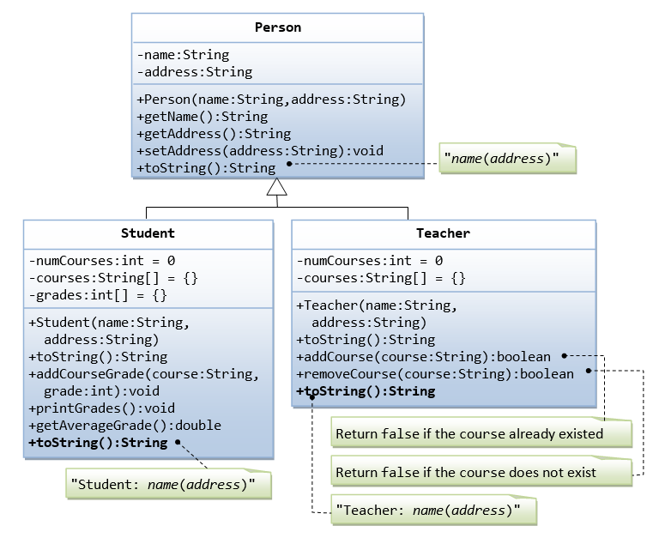

Suppose that we are required to model students and teachers in our application. We can define a superclass called Person to store common properties such as name and address, and subclasses Student and Teacher for their specific properties. For students, we need to maintain the courses taken and their respective grades; add a course with grade, print all courses taken and the average grade. Assume that a student takes no more than 30 courses for the entire program. For teachers, we need to maintain the courses taught currently, and able to add or remove a course taught. Assume that a teacher teaches not more than 5 courses concurrently.

package com.java;

public class Person1 {

private String name;

private String address;

public Person1(String name, String address) {

super();

this.name = name;

}

public String getName() {

return name;

}

public String getAddress() {

return address;

}

public void setAddress(String address) {

this.address = address;

}

public void setName(String name) {

this.name = name;

}

@Override

public String toString() {

return "Person [name=" + name + ", address=" + address + "]";

}

}package com.java;

import java.util.Arrays;

public class Student extends Person1{

private int numCourses=0;

private String[] courses=new String[30];

private int[] grades=new int[30];

public Student(String name,String address) {

super(name,address);

// TODO Auto-generated constructor stub

}

@Override

public String toString() {

return "toString()=" + super.toString() + "]";

}

public void addCourseGrade(String course,int grade) {

for(int i=0;i<courses.length;i++) {

if (courses[i]==null){

grades[i]=grade;

courses[i]=course;

break;

}

else

{

i++;

}

}

}

public void printGrades() {

for(int i=0;i<courses.length;i++) {

if(courses[i]!= null) {

System.out.println("course: "+ courses[i] + " grade: "+ grades[i]);

}

}

}

public double getAverageGrade() {

int n=0;

int sum=0;

for(int i=0;i< courses.length;i++){

if (courses[i]!=null){

sum=sum+grades[i];

n++;

}

}

return sum/n;

}

}package com.java;

public class Teacher extends Person1 {

public int numCourses =0;

public String[] courses ;

public Teacher(String name, String address) {

super(name,address);

}

public boolean addCourse(String course) {

return false;

}

public boolean removeCourse(String course) {

return true;

}

@Override

public String toString() {

return "Teacher [toString()=" + super.toString() + "]";

}

}

package com.java;

public class Main {

public static void main(String[] args) {

Person1 p = new Person1("sneha","dsnr");

Student s=new Student(p.getName(),p.getAddress());

Teacher t=new Teacher(p.getName(),p.getAddress());

s.addCourseGrade("java", 78);

s.addCourseGrade("python", 88);

s.addCourseGrade(".net", 56);

s.addCourseGrade("oracle", 98);

s.printGrades();

System.out.println("Average of all grade is "+s.getAverageGrade());

}

}

5.

